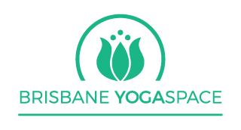
BRISBANE YOGA SPACE VINYASA TEACHER TRAINING

2022 Teacher Training Application Form

The Brisbane Yoga Space teacher training course is a Vinyasa yoga course covering the 8 limbs of yoga and will be suitable for those people with at least 1 years regular yoga practice and a proven commitment to further developing their understanding of yoga. The course will run over 10 months and 13 weekends from FEBRUARY 2020 - NOVEMBER 2022.

This course will be challenging, it will require commitment but it will be fun and it will be worth it! The course will inspire to find your own teaching voice so that you can be confident in sharing the ancient and wonderful teachings of yoga with your own students.

To apply for the course, please fill in the questionnaire below.

1. What has inspired you to do a Teacher Training course at this time?

2. Please tell us a little about your own yoga journey. How long have you practiced yoga, what style and what studio do you normally attend?

3. What is your own understanding of the word yoga and what does it mean to you?

4. What is your least favourite yoga pose and why do you think that is on more than only a physical level?

5. Think about the teachers that have inspired you on your yoga journey, what is it about that that resonates with you in particular?

6. Why do you practise yoga?

7. Is there anything else you would like to tell us to support your application to become a BYS accredited yoga teacher?

Namaste
Jacqui and Heather
Brisbane YogaSpace

