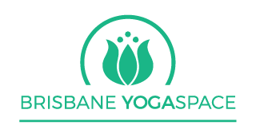
BYS 250 Hr Plus LEVEL 1 VINYASA TEACHER TRAINING
13 weekends, March to December 2021
Yoga Alliance accredited
Saturday 10.30am-5.30pm and Sunday 10.30am-3.30pm

Snapshot:
• Saturday 10.30am-5.30pm and Sunday 10.30-3.30pm. Please byo food and drinks.
• You have 10 months in total for you to complete the course assignments although we strongly suggest keeping up to date with coursework and assessment
• As well as study modules and homework, you must complete 10 Slow Flow classes, 15 general classes with Jacqui/Heather/Maitha, 5 Restorative classes, two class observations and one practice teaching class
• For the duration of the course, all classes at BYS are free of charge
• The course will include two final exams, one practical and one theory and homework which will be given at the end of each study module
• The course hours consist of 169 contact hours, plus over 30 hours of additional classes and 20 hours of non-contact hours

Modules will cover:

Techniques Training/Practice 100 contact hours, all with experienced Registered Yoga Teacher.

Training in the techniques and practice of: Asanas, pranayamas, meditation, main principles, teaching special populations, chanting, mantra.

Teaching Methodology (Total 20 hours) 10 contact hours, all with experienced Registered Yoga Teacher.
Principles of demonstration, observation, assisting/correcting, instruction, teaching styles, qualities of a teacher, and the student's process of learning, business skills, setting up classes.

Anatomy Studies for Yoga Teachers - Principles and Applications 20 contact hours.

Fitness knowledge components of physical fitness, bones, joints & common injuries, muscles and their actions, kinesiology of yoga asana, contraindications, movement patterns.

Practicum/Teaching (total 25 hours) 18 contact hours with Experienced Registered Yoga Teacher.
Teaching and assisting students in a class environment as well as observing and assisting in classes taught by others.

Yoga Philosophy/Lifestyle and Ethics for Yoga Teachers 20 contact hours
Includes the study of yoga philosophies, yoga lifestyle, and ethics for yoga teachers, yogic lifestyle.

___________________________________________________
250Hour Plus Level 1 consisting of 169 contact hours plus non-contact hours of coursework of over 20 hours, plus 37 hours additional class practicum to attend.

MODULES - please note subject to change*

Week 1
Saturday - Welcome, The meaning of Yoga and History, Surya Namaskar, Teaching principles and practise
Sunday - The Paths of Yoga, Patanjali's 8 Limbed path, Yoga's code of ethics, Bhagavad Gita introduction

Week 2
Saturday - Pranayama techniques, practicum, Vinyasa Yoga, BYS Sequencing, Centering and Warm up poses

Sunday - Bhakti Yoga, Yogi anatomy, Pranayama foundations

Week 3
Saturday - Bhagavad Gita skype lecture with Keren, Yogic anatomy and Chakras, Standing Postures part 1

Sunday - Pranayama session, Meditation Foundations

Week 4
Saturday - Mudras and Bhandas, Pranayama, mantra theory and practise, Standing Postures Part 2
Sunday - Meditation techniques and practicum, Sadhana guidelines, teaching practice

Week 5
Saturday – Meditation, Pranayama session, Centralising & Neutralising postures

Sunday - Sadhana review, Patanjali's Yoga Sutras

Week 6
Saturday - Mythology with Keren, Balance Postures, Student learning in a yoga class

Sunday - Chakras and the subtle bodies, Meditation teaching practice

Week 7
Saturday and Sunday - Anatomy and Physiology with Cecilia Flux

Week 8
Saturday - Class theming, Revolved Poses, Sanskrit review

Sunday - Anatomy and Physiology with Cecilia Flux

Week 9
Saturday - Chakra theory and practice, Hip openers and backbends, teaching practice

Sunday - Ayurveda Foundations, teaching practicum

Week 10
Saturday - Ethics for Yoga Teachers, Forward folds and twists, Restorative Yoga, teaching and assist practice

Sunday - Pranayama, mantra, teaching practice

Week 11
Saturday - Chant Practice, asana review, The Art of Assists and Adjustments, Mantra teaching practice, Arm balances

Sunday - Sequencing skills, Teaching Beginners, Core Flows, teaching practice

Week 12
Saturday - Safe sequencing principles, Class planning and preparation, Teaching and Business skills for yoga teachers, Teaching Private and Therapeutic yoga, Yoga and Common Injuries

Sunday - Pre-natal and kids yoga, Inversions

Week 13

Saturday - Written exam

Sunday - Practical assessment

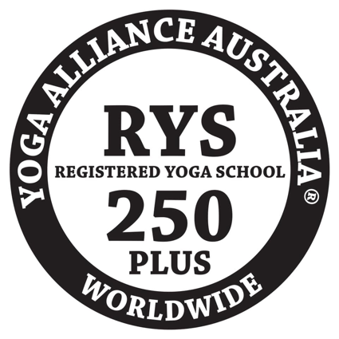

169 Contact hours plus class attendance of 37 hours, plus 20 non-contact hours of written assessment, additional class practicum and homework.

Additional classes to attend at BYS over 10 months:
10 Foundation classes
15 Flow w Jacqui/Heather
5 Restorative classes
2 Observes
1 Practise class

READING LIST:
Patanjali's Yoga Sutras - Satchitananda edition
Light on Yoga - BYS Iyengar
Bhagavad Gita - Eknath Easwaran edition
Mantra book - Thomas Ashley Farrand
The Heart of Yoga - T.K.V Desikachar

TO Express Your Interest: Please contact Jacqui or Heather to enquire about our next course or come in for a non-obligation chat about what we offer in this holistic Level 1 Yoga Teacher Training.

Namaste Jacqui Sellers and Keren Cooksey

